Online Appendix
Fig. A1
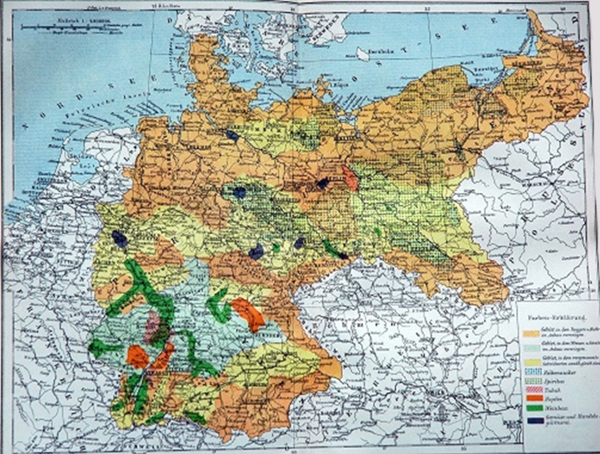
Source: „Karte der Landwirtschaft im Deutschen Reiche“, in: Brockhaus' Konversations-Lexikon,
14. Aufl., 1894-1897.
Fig. A2: Soil Quality Rating
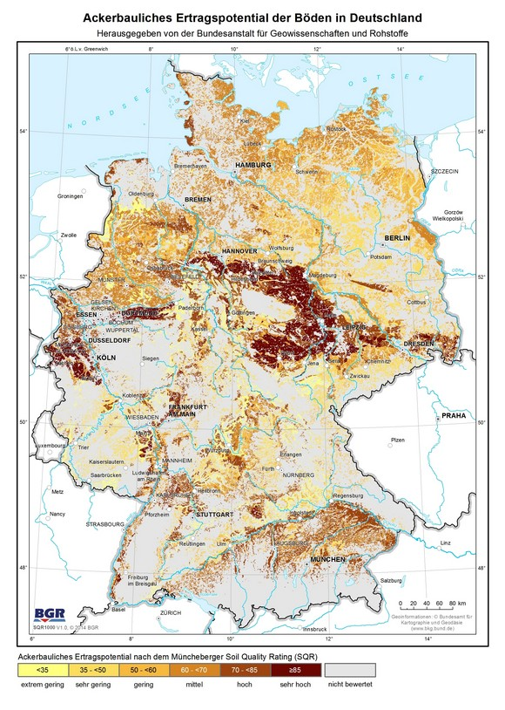
Source: Bundesanstalt für Geowissenschaft und Rohstoffe / Federal Institute for Geosciences and Natural Resources

Figure A3: Types of Soil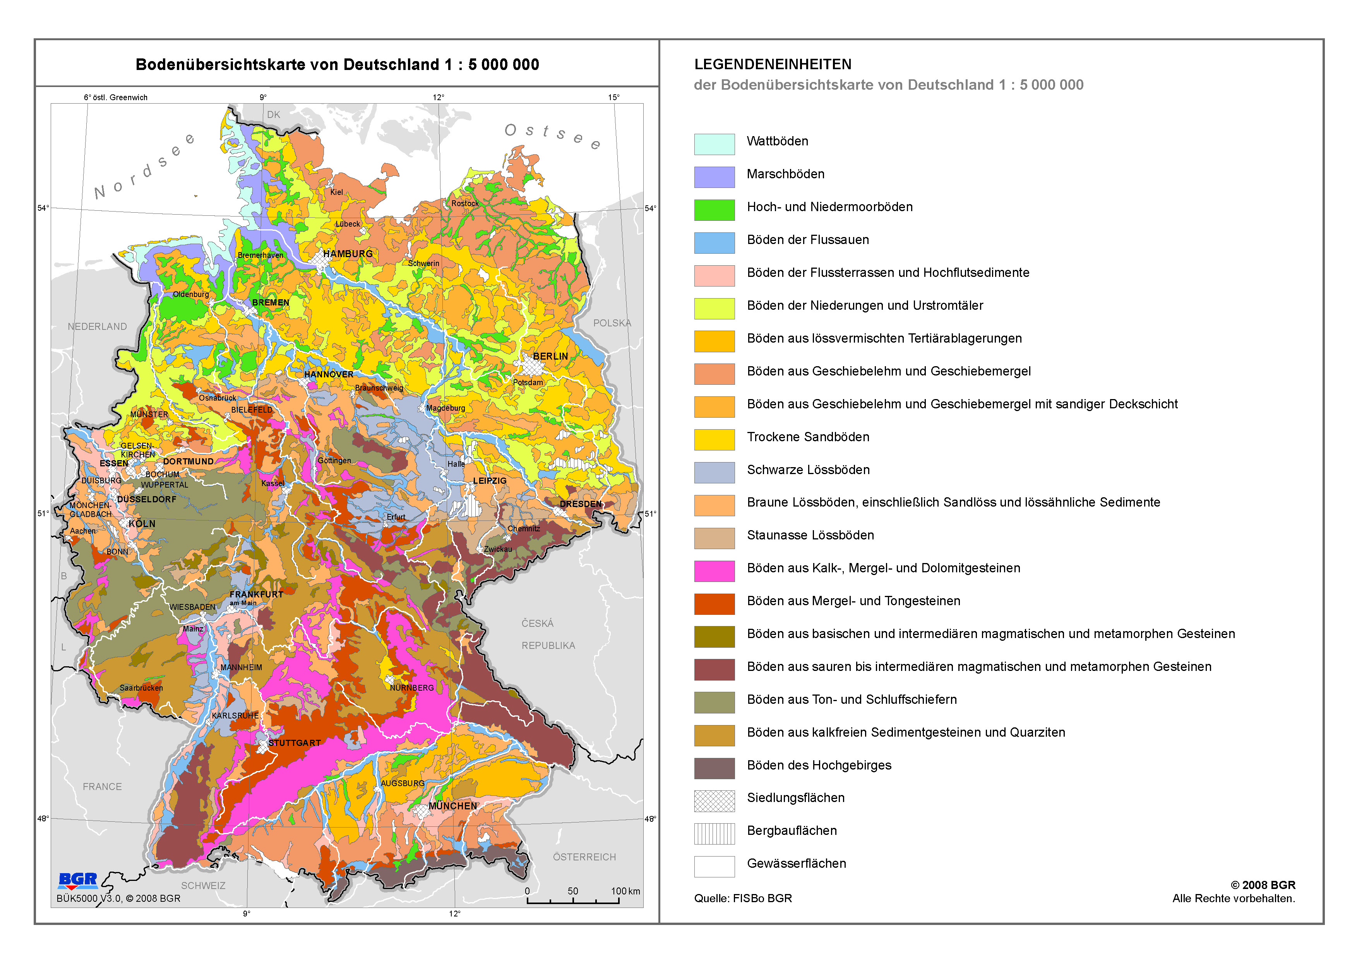
Source: Bundesanstalt für Geowissenschaft und Rohstoffe / Federal Institute for Geosciences and Natural Resources
Notes: The oat and rye agricultural areas are mostly characterized by rocky and clayey soils (Bavaria, Saxonia, Thüringia, Baden-Württemberg) as well as swampy soils (north-west), an indicator of lower agricultural productivity.

Table A1: OLS Regressions (additional robustness specifications)
 |  | (1) | (2) |  | (3) |  | (4) |  |  | (5) |  | (6) | (7) |  | (8)
 |  | 1904 to 1931 |  |  |  |  |  |  |  | 1931 to 2013
Log of crafts density, 1904 |  | 0.244** | 0.214** |  | 0.229** |  | 0.297**
 |  | (0.000) | (0.000) |  | (0.000) |  | (0.000)
Log of industry employment share, 1907 |  |  | -0.095** |  | -0.091** |  |  |  |  |  |  | -0.302** | -0.353**
 |  |  | (0.007) |  | (0.021) |  |  |  |  |  |  | (0.000) | (0.000)
Log of min. distance to coalfield |  |  | 0.009* |  | 0.029** |  |  |  |  |  |  | -0.018** | -0.005
 |  |  | (0.051) |  | (0.013) |  |  |  |  |  |  | (0.005) | (0.563)
Log of crafts density, 1931 |  |  |  |  |  |  |  |  |  | 0.366** |  | 0.319** | 0.287** |  | 0.384**
 |  |  |  |  |  |  |  |  |  | (0.000) |  | (0.001) | (0.007) |  | (0.000)
Controls
Historical states | Yes |  | Yes | Yes |  | Yes |  |  |  | Yes | Yes |  |  | Yes |  | Yes
Current states | No |  | No | Yes |  | Yes |  |  |  | No | No |  |  | Yes |  | Yes
_cons |  | 2.313** | 2.211** |  | 1.971** |  | 2.196** |  |  | 2.903** |  | 2.860** | 2.799** |  | 2.858**
 |  | (0.000) | (0.000) |  | (0.000) |  | (0.000) |  |  | (0.000) |  | (0.000) | (0.000) |  | (0.000)
N |  | 169 | 169 |  | 169 |  | 169 |  |  | 169 |  | 169 | 169 |  | 169
R² |  | 0.352 | 0.410 |  | 0.598 |  | 0.528 |  |  | 0.203 |  | 0.362 | 0.430 |  | 0.276
Robust standard errors are presented in parentheses. * p < 0.10, ** p < 0.05, *** p < 0.01

For the years 1904 and 1931 we use crafts association memberships per 1,000 inhabitants as our main explanatory variable. For 2013, we use the number of crafts people per 1,000 inhabitants. The southern German region of Bavaria and Baden-Württemberg are dropped from the analysis as the crafts associations that were widespread in the North did not exist in the South.

Table A2: Spatial Regression Results
 | (1) | (2) | (3) | (4) |  | (5) | (6)
 | Dep. Var. ln_density_2013 |  |  |  |  | IV 1st stage | IV 2nd stage
Log of crafts density, 1904 | 0.166** | 0.135** | 0.109* | 0.132** |  |  | .185**
 | (0.012) | (0.027) | (0.073) | (0.042) |  |  | (0.018)
Log of industry employment share, 1907 |  | -0.353** | -0.384** | -0.352** |  | -0.070* | -0.39***
 |  | (0.000) | (0.000) | (0.000) |  | (0.072) | (0.000)
Log of min. distance to coalfield |  | 0.003 | -0.017** | 0.003 |  | 0.027** | -0.000
 |  | (0.775) | (0.037) | (0.776) |  | (0.000) | (0.985)
Oats & rye agricultural region |  |  |  |  |  | 0.129**
 |  |  |  |  |  | (0.000)
State Controls | No | Yes | Yes | Yes |  | Yes | Yes
West Germany only | No | No | Yes | Yes |  | No | No
Constant | 3.998** | 3.486** | 3.352** | 3.491** |  | 2.436** | 3.423***
 | (0.000) | (0.000) | (0.000) | (0.000) |  | (0.000) | (0.000)
W
Log of crafts density, 1904 |  |  |  | 0.03
 |  |  |  | (0.914)
Log of crafts density, 2013 | -0.132** | -0.077* | 0.023 | -0.093 |  |  | -.0811*
 | (0.009) | (0.098) | (0.620) | (0.550) |  |  | 0.088
Error term | 0.744** | 0.740** | 0.692** | 0.742** |  |  | 4.264***
 | (0.004) | (0.005) | (0.025) | (0.005) |  |  | 0.004
N | 169 | 169 | 116 | 169 |  | 169 | 169
R² | 0.28 | 0.43 | 0.40 | 0.43 |  | - | -
Robust standard errors are presented in parentheses. * p < 0.10, ** p < 0.05, *** p < 0.01

For the years 1904 and 1926 we use crafts association memberships per 1,000 inhabitants as our main explanatory variable. For 2013, we use the number of crafts people per 1,000 inhabitants. The southern German region of Bavaria and Baden-Württemberg have been excluded as the crafts associations that were widespread in the North did not exist in the South.

An inverse distance weights matrix has been used.
Table A.3: List of historical and contemporary crafts trades

Crafts Association title 1895 according to the Imperial Statistics Office | Number of Businesses | English translation | Equivalent Crafts trade title 2021 according to the Trade and Crafts Code | Evaluation: Continuity in the type of work | Number of Businesses
Barbiere | 2.25% | Hairdresser | Friseure | strong continuity | 9.59%
Friseure und Perrückenmacher | 0.20% | Hairdresser and wigmaker | Friseure | strong continuity
Bäcker | 10.85% | Baker | Bäcker | strong continuity | 1.71%
Bandagisten | 0.28% | Orthopedic technician | Orthopädiemechaniker | continuity | 0.26%
Böttcher | 1.21% | Cooper | Böttcher | continuity | 0.01%
Brauer | 0.97% | Brewer | Brauer und Mälzer | strong continuity | 0.12%
Brunnenmacher | 0.11% | Well-digger | Brunnenbauer | continuity | 0.08%
Buchbinder | 0.73% | Book-binder | Buchbinder | strong continuity | 0.08%
Bürsten-, Pinselmacher | 0.26% | Brush-maker | Bürsten- und Pinselmacher | strong continuity | 0.00%
Conditoren | 0.80% | Confectioner | Konditoren | strong continuity | 0.37%
Dachdecker | 1.17% | Roofer | Dachdecker | strong continuity | 2.45%
Drechsler | 0.60% | Turner | Drechsler (Elfenbeinschnitzer) und Holzspielzeugmacher | strong continuity | 0.09%
Drucker (Buchdruck) | 0.43% | Printer (letterpress) | Drucker | continuity | 0.14%
Drucker (Stein-, Zink-, Kupfer-, Stahl) | 0.09% | Lithographic printer | Flexographen | continuity | 0.02%
Farbendruck | 0.01% | Printer (chromotypography) | Siebdrucker | continuity | 0.05%
Färber | 0.21% | Dyer | Textilgestalter | continuity | 0.06%
Feilenhauer | 0.18% | File cutter | Gold- und Silberschmiede | strong continuity | 0.51%
Gold-, Silber- u. Arbeiter | 0.25% | Goldsmith and silversmith | Gold- und Silberschmiede | strong continuity
Gas-, Wasserleitungs-, u. Installateure | 0.11% | Gas and water pipe plumbers | Installateur und Heizungsbauer | continuity | 7.69%
Gelb- und Rothgießer | 0.13% | Yellow and red founder | Metall- und Glockengießer | continuity | 0.02%
Gießer; Zinn-, Zink-, Metall-Gießer | 0.08% | Founder; tin/ zinc/ metal founder | Metall- und Glockengießer | continuity
Glockengießer | 0.00% | Bell founder | Metall- und Glockengießer | continuity
Gerber | 0.46% | Tanner | Gerber | strong continuity | 0.00%
Glaser | 0.63% | Glazier | Glaser | strong continuity | 0.60%
Graveure | 0.06% | Engraver | Graveure | strong continuity | 0.07%
Graveure |  |  | Edelsteinschleifer und -graveure | strong continuity | 0.01%
Handschuhmacher | 0.06% | Glove maker | Handschuhmacher | strong continuity | 0.00%
Hutmacher | 0.16% | Hatter | Modisten | strong continuity | 0.02%
Kammmacher | 0.02% | Comb maker |  | obsolete
Klempner | 1.85% | Plumber | Klempner | continuity | 0.65%
Korbmacher | 1.62% | Basket maker | Korb- und Flechtwerkgestalter | strong continuity | 0.01%
Kürschner | 0.24% | Furrier | Kürschner | strong continuity | 0.04%
Kupferschmiede | 0.37% | Coppersmith |  | obsolte
Maler; Lackierer | 3.57% | Painter; Lacquerer | Maler und Lackierer | continuity | 6.14%
Maurer | 4.09% | Bricklayer | Maurer und Betonbauer | strong continuity | 5.91%
 |  |  | Gerüstbauer | strong continuity | 0.50%
Metzger | 7.38% | Butcher | Fleischer | strong continuity | 1.66%
Müller | 3.59% | Miller | Müller | strong continuity | 0.08%
Mühlenbauer | 0.11% | Millwright |  | obsolte
Musikinstrumentenmacher | 0.06% | Musical instrument maker | Metalblasinstrumentenmacher; Holzblasinstrumentenmacher; Zupfinstrumentenmacher; Klavier- und Cembalobauer; Handzuginstrumentenmacher; Geigenbauer | strong continuity | 0.03%
Posamentirer | 0.06% | Trimmings Manufacturer | Textilgestalter (Sticker, Weber, Klöppler, Posamentierer, Stricker) | continuity | 0.06%
Sattler, Riemer | 1.90% | Saddler | Sattler und Feintäschner | continuity | 0.22%
Schiffbauer | 0.06% | Shipwright | Boots- und Schiffbauer | continuity | 0.07%
Schleifer | 2.66% | Grinder | Metallschleifer und Metallpolierer | strong continuity | 0.00%
Drahtzieher für Eisen, Kupfer | 0.00% | Wire drawer for iron, copper | Metallbauer | strong continuity | 3.79%
Schlosser (Nicht-Spezialisten) | 2.03% | Locksmith (non specialist) | Metallbauer | strong continuity
Nadler | 0.03% | Wire drawer | Metallbauer | strong continuity
Nagelschmiede | 0.10% | Nailsmith | Metallbauer | strong continuity
Bauschlosser | 0.62% | Building locksmith | Metallbauer | strong continuity
Geldschrankschlosser | 0.03% | Safe locksmith | Metallbauer | strong continuity
Herdschlosser | 0.05% | Hearth fitter | Metallbauer | strong continuity
Kunstschlosser | 0.04% | Artistic locksmith | Metallbauer | strong continuity
Wagenschlosser | 0.00% | Cartwright | Metallbauer | strong continuity
Maschinenschlosser | 0.10% | Machinist | Metallbauer | strong continuity
Eisendreher | 0.00% | Iron turner | Metallbauer | strong continuity
Schmiede (Nicht-Spezialisten) | 5.47% | Smithy (non specialist) | Metallbauer | strong continuity
Achsenschmiede | 0.03% | Axle smithy | Metallbauer | strong continuity
Ankerschmiede | 0.05% | Anchor smithy | Metallbauer | strong continuity
Faconschmiede | 0.00% | Facon smithy | Metallbauer | strong continuity
Hufschmiede | 1.40% | Farrier | Metallbauer | strong continuity
Kettenschmiede | 0.01% | Chain smithy | Metallbauer | strong continuity
Messerschmiede | 0.19% | Knive forge | Metallbauer | strong continuity
Sensenschmiede | 0.00% | Scythe forge | Landmaschinenmechaniker | continuity | 0.66%
Werkzeugschlosser | 0.01% | Tool maker | Feinwerkmechaniker | continuity | 2.19%
Zeug-, Werk-, Bohr-, Zirkelschmiede | 0.11% | Stuff/work/drill/compass forge | Feinwerkmechaniker | continuity
Schneider | 7.95% | Tailor | Maßschneider; Änderungsschneider | continuity | 0.35%
Schornsteinfeger | 0.38% | Chimney Sweep | Schornsteinfeger | strong continuity | 1.36%
Schreiner (Tischler) (Nicht-Spez.) | 6.25% | Joiner (non specialist) | Tischler | strong continuity | 5.35%
Bautischler | 1.22% | Carpenter | Tischler | strong continuity
Galanterietischler | 0.00% | Gallantry carpenter | Tischler | strong continuity
Kistenmacher | 0.04% | Box maker | Tischler | strong continuity
Kunsttischler | 0.03% | Cabinetmaker | Tischler | strong continuity
Laubschreiner | 0.01% | Foliage carpenter | Tischler | strong continuity
Modellschreiner | 0.03% | Model carpenter | Tischler | strong continuity
Möbeltischler | 0.87% | Furniture maker | Tischler | strong continuity
Sargmacher | 0.06% | Coffin maker | Tischler | strong continuity
Stuhlmacher | 0.06% | Chairmaker | Tischler | strong continuity
Webstuhlbauer | 0.00% | Loom builder | Tischler | strong continuity
Werkzeugtischler | 0.01% | Tool carpenter | Tischler | strong continuity
Parket-, Stab-, Patentboden-Tischler | 0.00% | Parquet, rod, patent floor carpenter | Estrichleger | strong continuity | 0.67%
Parket-, Stab-, Patentboden-Tischler |  | Parquet, rod, patent floor carpenter | Parketleger | strong continuity | 0.82%
Schuhmacher | 9.89% | Shoemaker | Schuhmacher | strong continuity | 0.20%
Seifensieder | 0.10% | Soap boiler |  | strong continuity | 0.00%
Seiler | 0.32% | Rope maker | Seiler | strong continuity | 0.01%
Siebmacher | 0.04% | Sieve maker |  | obsolete | 0.00%
Sporer; Büchsenmacher | 0.12% | Gunsmith | Büchsenmacher | continuity | 0.05%
Sonnen- und Regenschirmmacher | 0.06% | Umbrella maker | Schirmmacher | continuity | 0.00%
Spielwaarenverfertiger | 0.01% | Toy maker | Drechsler (Elfenbeinschnitzer) und Holzspielzeugmacher | strong continuity | 0.09%
Steinmetze | 0.65% | Stonemason | Steinmetzen und Steinbildhauer | strong continuity | 0.79%
Steinsetzer | 0.21% | Stone setter | Straßenbauer | continuity | 1.06%
 |  |  | Fliesen-, Platten- und Mosaiklege | strong continuity | 6.72%
 |  |  | Betonstein- und Terrazzohersteller | strong continuity | 0.09%
Stricker; Wirker | 0.26% | Knitter | Textilgestalter (Sticker, Weber, Klöppler, Posamentierer, Stricker) | continuity | 0.06%
Tuchmacher | 0.30% | Clothier | Textilgestalter (Sticker, Weber, Klöppler, Posamentierer, Stricker) | continuity
Weber | 3.24% | Weaver | Textilgestalter (Sticker, Weber, Klöppler, Posamentierer, Stricker) | continuity
Stuckateure | 0.25% | Plasterer | Stukkateure | strong continuity | 0.85%
Tapezierer | 0.57% | Paperhanger | Raumausstatter | continuity | 9.12%
Töpfer | 0.63% | Potter | Keramiker | strong continuity | 0.07%
Uhrmacher | 0.85% | Clockmaker | Uhrmacher | strong continuity | 0.30%
Vergolder | 0.08% | Gilder | Vergolder | strong continuity | 0.02%
Verfertiger grober Holzwaaren | 0.37% | Manufacturer of coarse wood products | Tischler | strong continuity
Wagner (Stellmacher) | 2.84% | Cartwright |  | obsolete | 0.00%
Zimmerer | 2.15% | Carpenter | Zimmerer | strong continuity | 2.48%
SUM | 100.00% |  |  |  | 76.42%

